## Sequence Diagrams

This section of the document will address the various sequence diagrams that have been developed for the Nutrition Application System.

SD1

* The following diagram illustrates the creation of a profile object. Upon input from a user, the persistent user object instantiates a Profile object with an identifier and control is passed back to User.

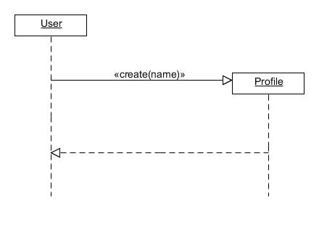

Figure 21 - Create User

SD2

* The following diagram illustrates the workflow and message passing to login to the system. The user is prompted for a password and the User object calls the Security object which checks the correctness of the password. Upon determining the password is correct, Security passes a message back stating the successful authentication.

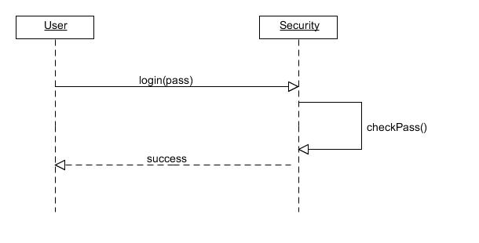

Figure 22 - Log Into Nutritional Application System

SD3

* The following diagram illustrates the procedure to logout. The User object changes to a logged out mode without passing messages or control.

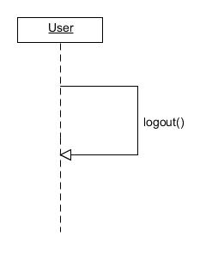

Figure 23 - Log Out of Nutritional Application System

SD4

* The following diagram illustrates the workflow and message passing to delete a profile. The user is prompted for a password and the User object calls the Security object with the identifier and password. With the correct password, the Security object destroys the Profile object. The Security object then passes control back to the User object.

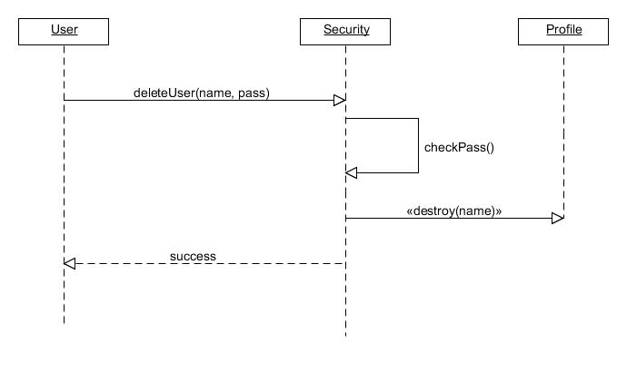

Figure 24 - Delete User

SD5

* The following diagram illustrates the workflow and message passing to input user statistics. A user is prompted his weight and height. These are then passed along to the Profile object which records the numbers. Control is then passed back to the User object which prompts for targets to be input. These targets are passed to the Profile object which records the targets, and Profile passes control to the User object.

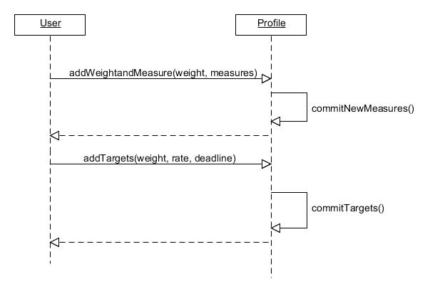

Figure 25 - Add User Statistics

SD6

* The following diagram illustrates the workflow and message passing to update user goals. A user is prompted his goal weight. This is then passed along to the Profile object which records the number. Control is then passed back to the User object which prompts for the user for a goal rate and deadline. These goals are passed to the Profile object which records the targets. Again control is then passed back to the User object which prompts for the user for their plan of activity and intake. This plan is passed to Profile which records it, and Profile passes control to the User object.

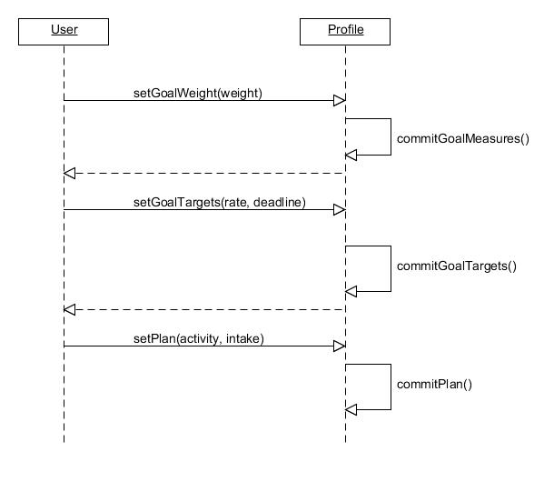

Figure 26 - Set User Goal Statistics

SD7

* The following diagram illustrates the workflow and message passing to update measurements and goals. The user is prompted for measurements and goals which are then passed to Profile to record before passing control back to User.

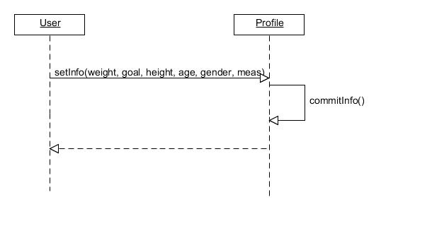

Figure 27 - Set/Update User Info

SD8

* The following diagram illustrates the workflow and message passing to add a friend. The user is prompted for the friend’s identifier which is then passed to Network which then passes control to the friend’s User object which confirms the friendship and then passes control back to Network which records the friendship and passes control to the original User.

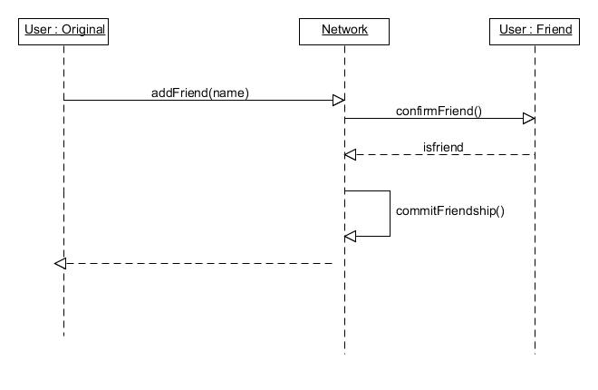

Figure 28 - Add Friend to User Friend List

SD9

* The following diagram illustrates the workflow and message passing to lookup a friend. The user inputs a name which is then passed to Network. Network looks up the name in a database and returns the results.

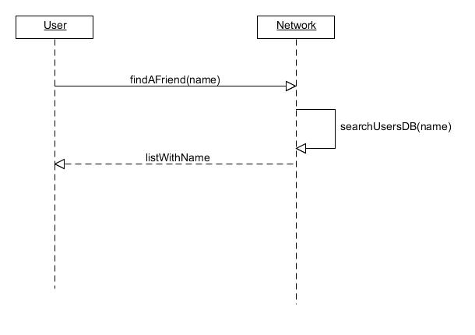

Figure 29 - Find a Friend

SD10

* The following diagram illustrates the workflow and message passing to create an alert. The user inputs a time and type of alert which is passed to Profile and recorded before returning.

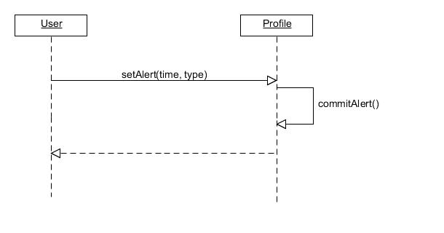

Figure 30 - Set User Alert

SD11

* The following diagram illustrates the workflow and message passing to activate an alert. Upon an interrupt, Profile messages User that an alert of the type indicated has occurred. The user then inputs an action to be taken against the alert. This is returned to Profile which then takes the action.

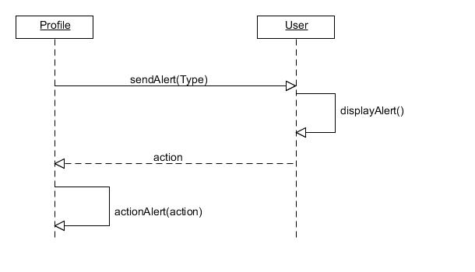

Figure 31 - Activate User Alert

SD12

* The following diagram illustrates the workflow and message passing to delete an alert. The user inputs an alert to delete and then User messages this alert to Profile which in turn deletes the alert before passing control back to User.

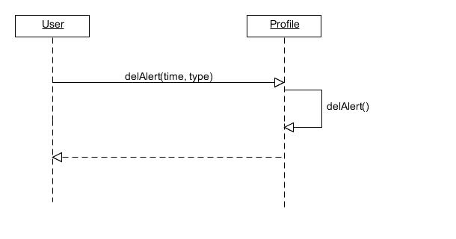

Figure 32 - Delete User Alert

SD13

* The following diagram illustrates the workflow and message passing to create a new food type. The user inputs the type of food, the name of the food, and nutritional information on the food which is passed to Profile which records this information and returns to User.

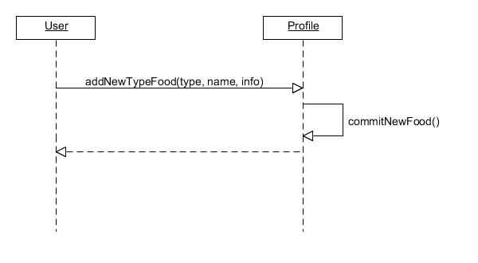

Figure 33 - Add New Food Item to User Profile

SD14

* The following diagram illustrates the workflow and message passing to search for a food from a database. The user inputs the type of food. The food database receives this as input and returns all food of that type. The user then makes a selection from this list, and this selection is passed to the database which then returns all nutritional information about the food.

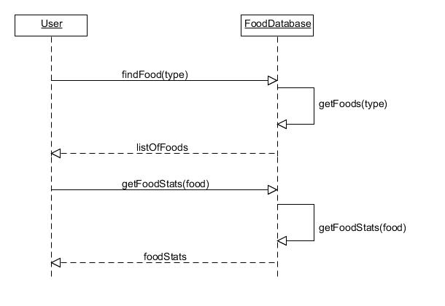

Figure 34 - Search for Food Item in Food Database

SD15

* The following diagram illustrates the workflow and message passing to search for a food from a database. The user inputs the type of food. The food database receives this as input and returns all food of that type. The user then makes a selection from this list, and this selection is passed to the database which then returns all nutritional information about the food.

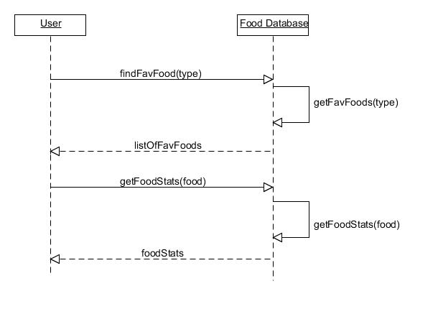

Figure 35 - Search for Favorite Food Item in Food Database

SD16

* The following diagram illustrates the workflow and message passing to record an exercise. The user inputs the date, duration, and type of exercise which is passed to Profile which records this information and returns to User.

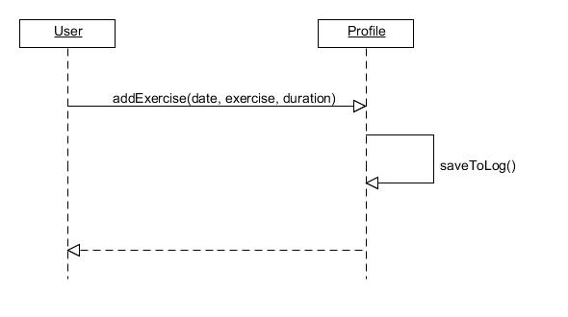

Figure 36 - Add Exercise to User Profile

SD17

* The following diagram illustrates the workflow and message passing to create a new exercise type. The user inputs the type, name, and statistics of the exercise which is passed to Profile which records this information and returns to User.

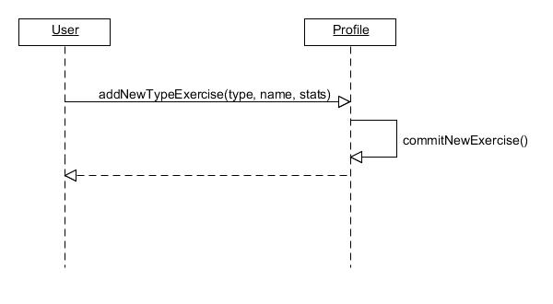

Figure 37 - Add User Defined Exercise to User Profile